**Key Exchange using Diffie-Hellman**

**Code**

**Server**

import socket

import random

# Diffie-Hellman key exchange

def generate_prime():

prime = [2, 3, 5, 7, 11, 13, 17, 19, 23, 29, 31, 37, 41, 43, 47, 53, 59, 61, 67, 71, 73, 79, 83, 89, 97]

u_n = random.sample(prime, len(prime))

p, q = u_n[1], u_n[2]

return p,q

def generate_key_pair(p, g):

#private_key = random.randint(2, p - 1)

private_key =int(input("enter key: "))

public_key = pow(g, private_key, p)

return private_key, public_key

def calculate_shared_secret(private_key, public_key, p):

return pow(public_key, private_key, p)

# Set up the server

server_socket = socket.socket(socket.AF_INET, socket.SOCK_STREAM)

server_socket.bind(('192.168.1.24', 8080))

server_socket.listen(1)

print("Waiting for a connection...")

# Accept a connection

client_socket, client_address = server_socket.accept()

print(f"Connection from {client_address}")

p,g= generate_prime()

# Send primes to the client

primes_message = f"{p},{g}"

client_socket.send(primes_message.encode())

bob_private_key, bob_public_key = generate_key_pair(p, g)

print("Public key of b: ",bob_public_key)

client_socket.send(str(bob_public_key).encode())

client_public_key = int(client_socket.recv(1024).decode())

print("Public key of A: ",client_public_key)

shared_secret_bob = calculate_shared_secret(bob_private_key, client_public_key, p)

print("Shared secret key with A:", shared_secret_bob)

# Close the connection

client_socket.close()

server_socket.close()

**Client**

import socket

import random

def generate_key_pair(p, g):

#private_key = random.randint(2, p - 1)

private_key = int(input("Enter Private key"))

public_key = pow(g, private_key, p)

return private_key, public_key

def calculate_shared_secret(private_key, public_key, p):

return pow(public_key, private_key, p)

# Set up the client

client_socket = socket.socket(socket.AF_INET, socket.SOCK_STREAM)

client_socket.connect(('192.168.1.47', 8080))

# Diffie-Hellman key exchange

primes_message = client_socket.recv(1024).decode()

p, g = map(int, primes_message.split(','))

print(f"Prime no.: {p} \n value of g: {g}")

alice_private_key, alice_public_key = generate_key_pair(p, g)

print("Public key of A: ",alice_public_key)

client_socket.send(str(alice_public_key).encode())

server_public_key = int(client_socket.recv(1024).decode())

print("Public key of B: ",server_public_key)

shared_secret_alice = calculate_shared_secret(alice_private_key, server_public_key, p)

print("Shared key with B:", shared_secret_alice)

# Close the connection

client_socket.close()

**Output**

**First execute the server program**

**Server wating for connection**



**Then execute the client program**

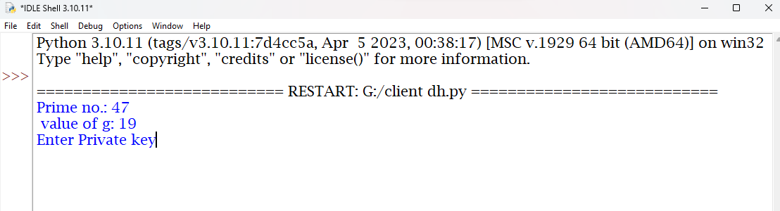

**Server side output**

**Connection successfully**



**Client enter the Private key then server enter the private key**

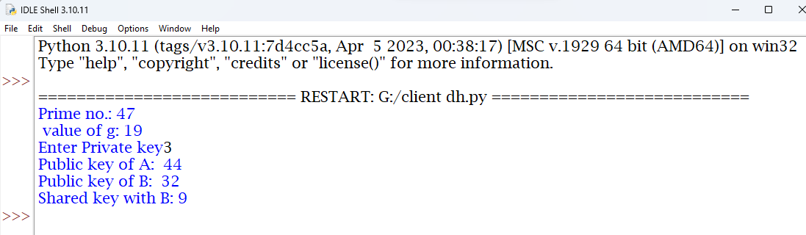

**Output at server side**

